Requesting a change to your Research Council project
The following steps should be followed when the following grant changes are required:
Extension to the end date of the grant
Extension to the submission date of the final report
Significant budget / staffing changes
Change of Principal or Co-Investigators
Request to suspend or terminate a grant
Request to resume a grant following suspension
Transferral of a grant to another institution

- Log into the JeS system at https://je-s.rcuk.ac.uk/Jes2WebLoginSite/Login.aspx

- Select ‘Documents’ from the menu:
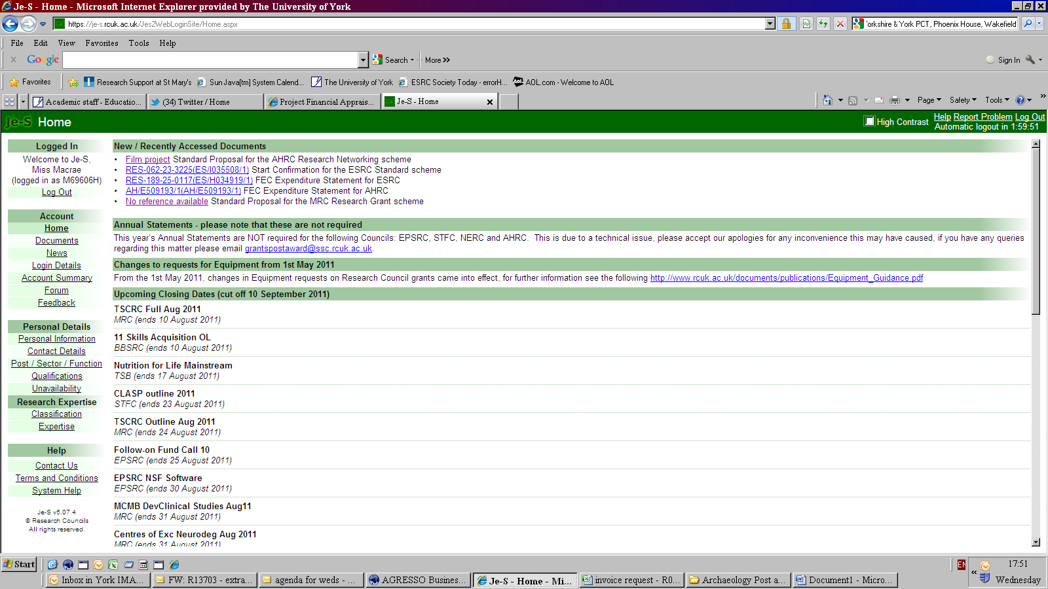

- Select ‘Maintain grants’

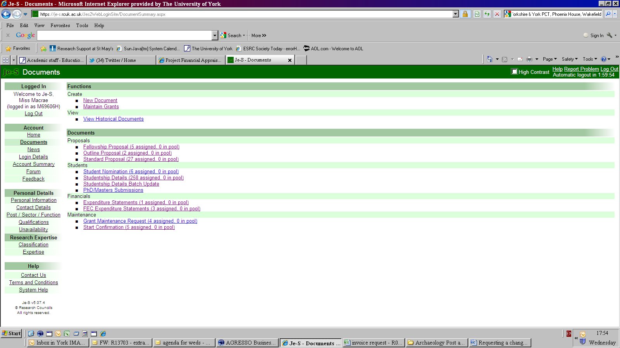

- Search for relevant council and find the relevant grant.
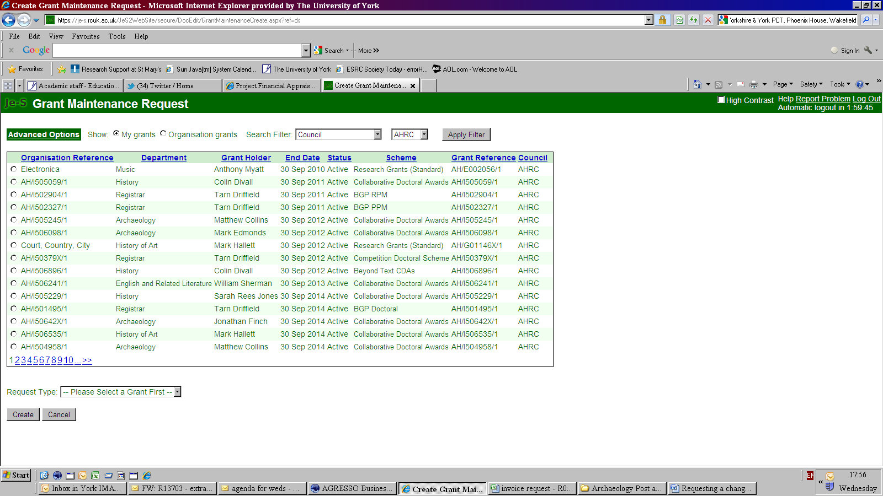

- Click on the circle next to the grant you wish to request a change on. Then select the request type and ‘create’

- A document will be created for you to complete. Once you have completed all the required sections you will see that the red cross becomes a green tick. You then select ‘submit document’. The document is then forwarded to the university submitter pool to be processed by the relevant Grant Coordinator.

